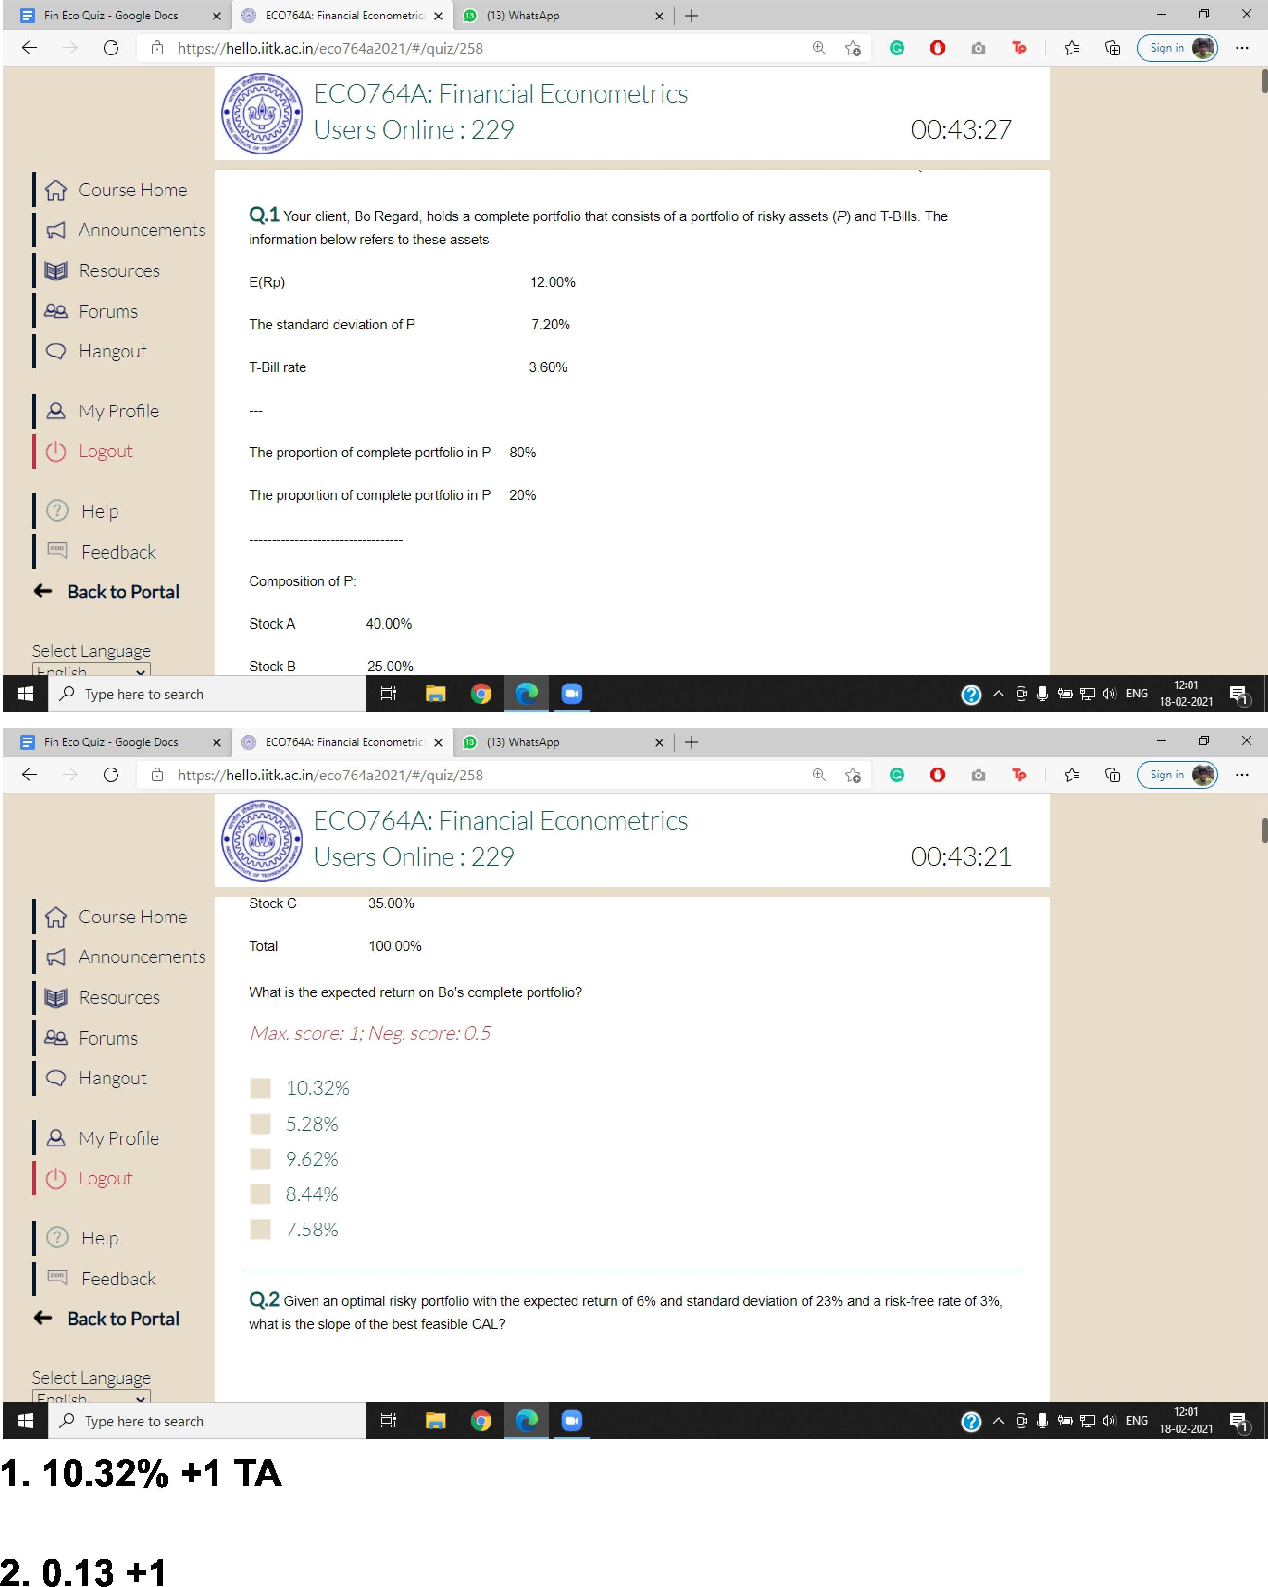

0 X

* En Eco Quiz - Google Dors X 0 EC07545 Financial Econometric **x a** (13) WhaftApp

EC0764A: Financial Econometrics

Users Online : 229 00:43:27

5 X

(13) Wha.APP

100.00%

Total

Select Language

* Type here to search

**1. 10.32% +1 TA**

12:01

**7_;1** 51 ENG 2021 **ip;**

0 A https://h e I o.i it k.a i n/eco 764a 2021/#/q uiz/258

**0. ® o 0 To ca (sig.,.**

**Q.1** Your client, Bo Regard, holds a complete portfolio that consists of a portfolio of risky assets (J) and T-Bills. The

|  |  |
| --- | --- |
| information below refers to these assets. |  |
| E(13p) | 12.00% |
| The standard deviation of P | 7.20% |
| T-Bill rate | 3.60% |

The proportion of complete portfolio in P 80%

The proportion of complete portfolio in P 20%

Composition of P:

Stock A 40.00%

IResources IQA Forums

IQ Hangout

IA My Profile ILogout

I® Help IFeedback

<— Back to **Portal**

What is the expected return on Bo's complete portfolio?

*Max. score: 1; Neg. score: 0.5*

**Q**.2 Given an optimal risky portfolio with the expected return of 6% and standard deviation of 23% and a risk-free rate of 3%, what is the slope of the best feasible CAL?

**2. 0.13 +1**

IQ. Course Home
  
ICI Announcements
  
Resources

I9P. Forums IQ Hangout

IA My Profile I(I) Logout

I® Help

Iq Feedback 4 Back to Portal

12:01

(2) L' **111-;1** ENS 18-02-2021

**49 0 0 ( sign in 4?**

Select Language

rr I ich

Stock B

,0 Type here to search

* Fin Eco Quiz - Google Docs X EC07.54A1 Financial Econometric X

https://h e I I oi it k.a c.inieco764a2021/#/quiz/258

25.00%

IQ. Course Home ICI Announcements

EC0764A: Financial Econometrics Users Online : 229

stock C 35.00%

00:43:21

III 10.32%

* 5.28%
* 9.62%
* 8.44%
* 7.58%

|  |  |
| --- | --- |
| la Fin Eco Quiz - Google Dors X 0 EC0754A, Financial Econometric **x** (13) WhaftApp | *0* X |

5 0 A https://h e I I oi it [k.ac.in/eco764-a2021/#/quiz/258](http://k.ac.in/eco764-a2021/#/quiz/258) **0. ® 0 l v cci (sign in**

EC0764A: Financial Econometrics

IQ' Course Home
  
ICI Announcements
  
Resources

I9P. Forums IQ Hangout

IA My Profile I(I) Logout

I® Help

Iq Feedback (— Back to Portal

Select Language

I Fr-mlich vI



Users Online : 229 00:43:16

II 0.39

* 0.64
* 0.08
* 0.13
* 0.36

**Q**.3 If a portfolio had a return of 18%, the risk-free asset return was 5%, and the standard deviation of the portfolio's excess returns was 34%, the risk premium would be

*Max. score: 1; Neg. score: 0.5*

18% 13% 49% *12%*

|  |  |
| --- | --- |
| P Type here to search | 12:01  (2) 444. 111_;1 11:1 ENG W.  1E-02-2021 1 |
| **3. 13% (AS) +1** |  |

|  |  |  |  |  |  |  |  |  |  |
| --- | --- | --- | --- | --- | --- | --- | --- | --- | --- |
| **gi** Fin Eco Quiz - Google Sacs X J G EC0754A1 Financial Econometric X 1 iD 113) Wha13App | | | | |  |  |  |  |  |
| X I + |  |  |  |  |
|  |  |  |  |  |
| 0 A <https://hello.iitk.ac.in/eco764a2021/#/quiz/258> | | | | |  |  | d, 0 0 **C Sign in** | | |
|  |  |  |  |  |  |  |  |  |  |
|  |  |  |  |  |  |  |  |  |  |

|  |  |
| --- | --- |
|  | EC0764A: Financial Econometrics Users Online : 229 |

**Q**.4 You have been given this probability distribution for the holding-period return for KMP stock:

State of the economy Probability H PR

|  |  |  |
| --- | --- | --- |
| Boom | 0.30 | 18% |
| Normal Growth | 0.50 | 12% |
| Recession | 0.20 | -5% |

What is the expected standard deviation for KMP stock?

00:43:11

ICourse Home ICI Announcements

Resources

I,29. Forums IHangout

IA My Profile I(I) Logout

I° Help

I11 Feedback 4- Back to **Portal**

Select Language

1Fricrlich v I

P Type here to search

*Max. score: 1; Neg. score: 0.5*

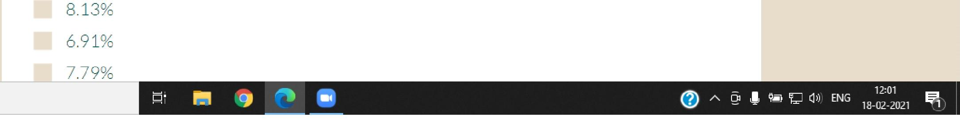

**4. 8.13 (AS) +1**

0 A https://h e I I oi it k.a c. i n/eco 764a 2021/#/q uiz/258 0. o **so *ci* cci (signine**

**la** Fin Eco Quiz - Google Dors X 0 EC071645 Financial Econometric X **a** (13) WhaftApp

*0* **X**

EC0764A: Financial Econometrics

IQ' Course Home
  
ICI Announcements
  
Resources

Iag Forums IQ Hangout

IA My Profile I(I) Logout

I® Help

Iq Feedback 4 Back to Portal

Select Language

I FrIrrlich vl



Users Online : 229 00:43:06

**Q**.5 An investor who wishes to form a portfolio that lies to the right of the optimal risky portfolio on the capital allocation line must

*Max. score: 1; Neg. score: 0.5*

II borrow some money at the risk-free and invest in the optimal risky portfolio

* lend some of her money at the risk-free rate
* Invest only in risky securities

such a portfolio cannot be formed

* borrow some money at the risk-free rate and invest in the optional risky portfolio and invest in risk securfties

**Q**.6 If a portfolio had a return of 12%, the risk-free asset return was 4%, and the standard deviation of the portfolio's excess returns was 25%, the Sharpe measure would be

*Max. score: 1; Ne:. score: 0.5*

**A I 9' 117 ill ENS** 18:02121

fi Type here to search

**5. LAST OPTION (AS)**

**5. E (last option)**

|  |  |
| --- | --- |
| **10** Fin Eco Quiz - Goog le Docs X • - • EC0754A1 Financial Econometric X **al** (13) Wha13App | *0* X |

0 A https://h e I I oi it k.a c. i n/eco 764a 2021/#/q uiz/258 0 0 Ca 're n cc) csignine

ICourse Home ICI Announcements

Resources

IQA Forums IHangout

IA My Profile I(I) Logout

I(1) Help IFeedback

€ Back to Portal

Select Language

nlich vi

I

|  |  |
| --- | --- |
|  | EC0764A: Financial Econometrics  Users Online : 229 00:43:01 |

**Q**.6 If a portfolio had a return of 12%, the risk-free asset return was 4%, and the standard deviation of the portfolio's excess returns was 25%. the Sharpe measure would be

*Max. score: 1; Neg. score: 0.5*

* 0.04
* 0.12
* 0.32
* 0.16

MI 0.25

**Q**.7 Which of the following statement(s) is(are) **true** regarding the variance of a portfolio of two risky securities?

*Max. score: 1; Neg. score: 0.5*

|  |  |
| --- | --- |
| Type here to search | 12112  5 **I cw T7**ma-r2-m1 |
| **6. 0.32 +1** |  |

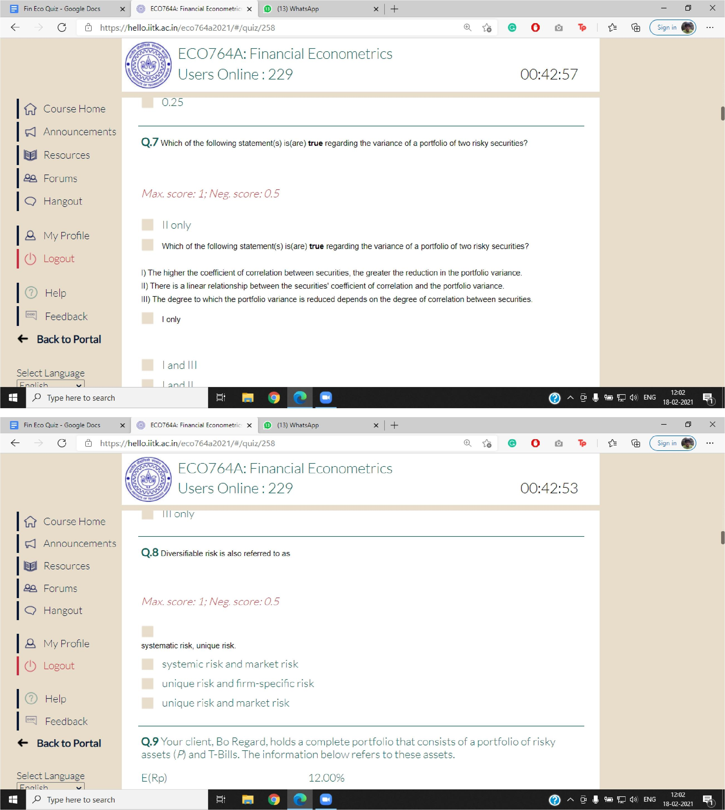

*0* **X**

**® o 0 Tp ca (sig.,.**

**la** Fin Eco Quiz - Google Does X 0 EC0764.4, Financial Econometric X **a** (131 WhaftApp

0 A https://h e I I oi it k.a c. i Rieco 764a 2021/#/g uiz/258

EC0764A: Financial Econometrics

Users Online : 229 00:42:57

I and **Il**l

I It

Fri

Select Language

Mich

*P* Type here to search

12:02

(2) A**I** 44. 111_;1 d,)EN G

18-02-2021 1

IQ' Course Home ICI Announcements IResources

I9P. Forums

IQ Hangout

IA My Profile I(I) Logout

I® Help Iq Feedback

**# Back to Portal**

0.25

**Q**.7 Which of the following statement(s) is(are) **true** regarding the variance of a portfolio of two risky securities?

*Max. score: 1; Neg. score: 0.5*

**II** only

Which of the following statement(s) is(are) **true** regarding the variance of a portfolio of two risky securities?

1. The higher the coefficient of correlation between securities, the greater the reduction in the portfolio variance.
2. There is a linear relationship between the securities' coefficient of correlation and the portfolio variance.
3. The degree to which the portfolio variance is reduced depends on the degree of correlation between securities.

I only

X I +

**5 X**

**® o 0 Tp**

**IN** Fin Em Quiz - Google Dors. X I **e** EC0764A, Financial Econometric X I ID 113) WhaiApp

https://h el lo.iit k.a c.inieco764a2021/#/quiz/258

E(Rp)

Select Language

**drrlich** *P* Type here to search

**12) .w** 0:.) ENG 12'02 gl

18-02-2021 1

12.00%

systematic risk, unique risk.

* systemic risk and market risk
* unique risk and firm-specific risk **IP** unique risk and market risk

**Q.9** Your client, Bo Regard, holds a complete portfolio that consists of a portfolio of risky assets *(P)* and T-Bills. The information below refers to these assets.

ICourse Home ICI Announcements

IW/ Resources I9P. Forums IQ Hangout

**Q**.8 Diyersilable risk is also referred to as

*Max. score: 1; Neg. score: 0.5*

I'21 My Profile I(I) Logout

I ° Help

IFeedback

**€ Back to Portal**

EC0764A: Financial Econometrics Users Online : 229

III only

00:42:53

la Fin Eco Quiz - Google Dors X 0 EC07545 Financial Econometric X **a** (13) WhaftApp

0 X

|  |  |  |
| --- | --- | --- |
| C 0 A https://h e I I o.i it k.a c. i n/eco 764a 2021/#/q uiz/258 | ®. 0 To = cci (signin | |
|  |  |  |

|  |  |  |  |
| --- | --- | --- | --- |
|  | EC0764A: Financial Econometrics  Users Online : 229 00:42:49 | | |

**Q.9** Your client, Bo Regard, holds a complete portfolio that consists of a portfolio of risky assets *(/* and T-Bills. The information below refers to these assets.

IQ. Course Home ICI Announcements IResources

I9P. Forums

IQ Hangout

IA My Profile I(I) Logout

I® Help

Iq Feedback 4 Back to Portal

E(Rp) 12.00%

The standard deviation of P 7.20%

T-Bill rate 3.60%

The proportion of the complete portfolio in P 80%
  
The proportion of the complete portfolio in P 20%

Composition of P:

Stock A 40.00%

|  |  |  |
| --- | --- | --- |
| Select Language | Stock B | 25.00% |
|  |

Type here to search

Fin Eco Quiz - Google Doss X EC07.54A1 Financial Econometric X

e I I o.i it k.a c. i n/eco 764a 2021/#/q uiz/258

**e 0 CI ( Sign in 4?**

:2

0

**4 7-;1 r** 12

**""** ENS 10-02-2021

**(13) Wha.APP** x I + 5 X

IQ. Course Home ICI Announcements

EC0764A: Financial Econometrics Users Online : 229

**MJJA,JJO** _1LVLIl L.

Total 100.00%



00:42:45

|  |
| --- |
| IResources IQA Forums  IQ Hangout  IA My Profile ILogout  I® Help IFeedback  <— Back to **Portal** |

Select Language

P Type here to search

What are the proportions of stocks A, B, and C, respectively, in Bo's complete portfolio?

*Max. score: 1; Neg. score: 0.5*

* 8%, 5% and 7%
* 40%. 25%, 35%
* 32%, 20% and 28% II

16%,10% and 14% 20%1_2.5% and 17.5%

**Q**.10 An investor invests 35% of his wealth in a risky asset with an expected rate of return of 0.18 and a variance of 0.10 and 65% in a T-bill that pays 46t. His portfolio's expected return and standard deviation are and
  
respectively.

|  |
| --- |
| 0i7ENG 12:02  18 02-2 0,1 **ip1** |

la Fin Eco Quiz - Google Does X 0 EC0764.4, Financial Econometric **x a** (13) WhaftApp

0 **X**

|  |  |  |
| --- | --- | --- |
| 0 A https://h e I I oi it k.a c. i n/eco 764a 2021/#/q uiz/258 | ®. 0 To .= cci (sig.,. | |
|  |  |  |

|  |  |  |  |
| --- | --- | --- | --- |
|  | EC0764A: Financial Econometrics  Users Online : 229 00:42:42 | | |

**Q**.10 An investor invests 35% of his wealth in a risky asset with an expected rate of return of 0.18 and a variance of 0.10 and 65% in a T4Dill that pays 4%. His portfolio's expected return and standard deviation are and
  
respectively.

IQ. Course Home
  
ICI Announcements
  
Resources

I9P. Forums IQ Hangout

IA My Profile I(I) Logout

I® Help

Iq Feedback 4 Back to Portal

*Max. score: 1; Neg. score: 0.5* 0.089 and 0.111

* 0.087 and 0.063
* 0.087 and 0.144
* 0.096 and 0.126

**Q.11** Consider the following probability distribution for stocks A and B:

|  |  |
| --- | --- |
| Select Language  rrlich  Type here to search State Probabilit Return on Stock A Return on Stock B | 6 144, ENG 12:02 =.  18-02-2021 |

|  |  |
| --- | --- |
| Fin Eco Quiz - Google Doss X EC07.54A1 Financial Econometric X el (13) Wha.App  https://h e I I oi it k.a c. i n/eco 764a 2021/#/q uiz/258 | 5 X |
| 0 0 **0 ( sign in 4?** |

|  |  |  |  |  |  |
| --- | --- | --- | --- | --- | --- |
|  |  |  |  |  |  |
| EC0764A: Financial Econometrics Users Online : 229 | | |  | 00:42:38 |

**Q.11** Consider the following probability distribution for stocks A and B:

IQ. Course Home ICI Announcements

IResources IQA Forums

IQ Hangout

IA My Profile ILogout

I® Help IFeedback

<— Back to **Portal**

|  |  |  |
| --- | --- | --- |
| Select Language  P Type here to search |  |  |
| **r■I** | **i**  12:02  **i7**0 ENG is so,„ |

|  |  |  |  |
| --- | --- | --- | --- |
| State | Probability | Return on Stock A Return on Stock B | |
| 1 | 0.10 | 10% | 8% |
| 2 | 0.20 | 13% | 7% |
| 3 | 0.20 | 12% | 6% |
| 4 | 0.30 | 14% | 9% |
| 5 | 0.20 | 15% | 8% |

If you invest 40% of your money in Aand 60% in B, what would be your portfolio's expected rate of return and standard deviation?

la Fin Eco Quiz - Google Does X 0 EC07645 Financial Econometric X **a** (13) WhaftApp

*0* X

111 9.9% and 1.1%

* 9.9% and 3%
* 11% and 1.1%
* 11% and 3%

MI None of the above options

|  |  |  |
| --- | --- | --- |
| 0 A https://h e I oi it k.a c. i n/eco 764a 2021/#/q uiz/258 | **0. ® o 0 To cci (sig.,.** | |
|  |  |  |

|  |  |  |
| --- | --- | --- |
|  | EC0764A: Financial Econometrics  Users Online : 229 00:42:34 | |

|  |
| --- |
| IQ. Course Home ICI Announcements IResources  I9P. Forums  IQ Hangout |

IA My Profile I(I) Logout

I® Help

Iq Feedback 4 Back to Portal

Select Language

olich

Type here to search

**Q**.12 Consider the following probability distribution for stocks A and B:

|  |  |  |  |
| --- | --- | --- | --- |
| State | Probability | Return on Stock A Return on Stock B | |
| 1 | 0.10 | 10% | 8% |
| 2 | 0.20 | 13% | 7% |
| 3 | 0.20 | 12% | 6% |

•

of

12:02

AI 4A. 7_;1 115 G

18-02-2021 1

|  |  |
| --- | --- |
| Fin Eco Quiz - Google Does X ECO7fi4A1 Financial Econometric X I ID (13) Whal3App  https://h e I l oi it k.a c. i n/eco 764a 2021/#/q uiz/258 | 5 X |
| €1 0 **0 ( sign in 4?** |

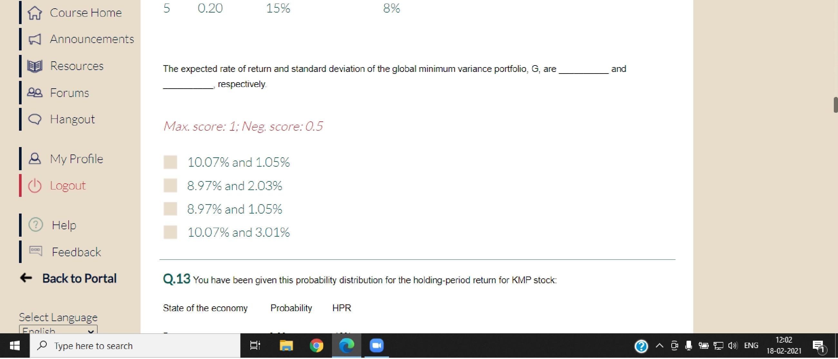

IQ. Course Home ICI Announcements

IResources IQA Forums

IQ Hangout

IA My Profile ILogout

I® Help IFeedback

<— Back to **Portal**

Select Language

P Type here to search

1102

**7_;1** (:1 ENG 4,2 2021 **ip;**

5 0.20 15% 8%

The expected rate of return and standard deviation of the global minimum variance portfolio, G, are and

respectively

*Max. score: 1; Neg. score: 0.5*

**b.** 10.07% and 1.05%

* 8.97% and 2.03%

II 8.97% and 1.05% MI 10.07% and 3.01%

**Q**.13 You have been given this probability distribution for the holding-period return for KMP stock:

* •

State of the economy Probability HPR

|  |  |  |  |  |  |
| --- | --- | --- | --- | --- | --- |
|  |  |  |  |  |  |
| EC0764A: Financial Econometrics Users Online : 229 | | |  | 00:42:30 |

la Fin Eco Quiz - Google flocs X I 0 EC07545 Financial Econometric X **a** (13) WhaftApp I X SodaPDF-merged-Merging-Re, X I ±

|  |  |  |  |  |
| --- | --- | --- | --- | --- |
| **0 0** https://h e I o.i it k.a c.i n/eco 764a 2021/#/q uiz/258 | | |  | ®, TO |

YYY

IQ Course Home I'71 Announcements Iai Resources

Iagk Forums

IQ Hangout

I12' My Profile I(1-) Logout

I® Help Iq Feedback

**4— Back to Portal**

Select Language .,I -k

*P* Type here to search

EC0764A: Financial Econometrics Users Online : 240

**IL! CAI**

What is the expected holding-period return for KMP stock?

*Max. score: 1; Neg. score: 0.5*

10.40% 9.32% 11.63%

of PTI

x I +

|  |  |  |  |
| --- | --- | --- | --- |
| 49 O **CI** TO CEl (Sign in 4110 | | | ". |
| 00:17:48 |  |  |  |
|  |
|  |
| 031 **ENG** | | 12:27  18-02-2021 | I |
|  | |  |  |
|  | | *m* | *X* |

8. **® L-= (signin •**



Fin Eco Quiz - Google Docs X I EC0764k Financial Econometric X r(13) What pp

C 0 <https://hello.iitk.ac.in/eco764a2021/#/quiz./258>

**Q.13** You have been given this probability distribution for the holding-period return for KMP stock:

State of the economy Probability HPR

Boom 0.30 18%

Normal Growth 0.50 12%

Recession 0_20 -5%

|  |  |  |  |
| --- | --- | --- | --- |
|  | EC0764A: Financial Econometrics Users Online : 229 | | 00:42:23 |

|  |
| --- |
| ICourse Home ICI Announcements IResources  I*PA.* Forums  IQ Hangout  I‘21 My Profile I(1-) Logout  I® Help  I(1 Feedback **4— Back to Portal** |

Select Language mrck,

*Max. score: 1; Neg. score: 0.5*

|  |  |
| --- | --- |
| **_ .1111 Id**  **P'11 co** |  |
| ***C!)* Y.' 1 44 'CI** ENG 18-107:021 |

**Q.14** The capital allocation line provided by a risk-free security and *N* risky securities is

*Max. score: 1; Neg. score: 0.5*

the line that connects the risk-free rate and the global minimum-variance portfolio of the risky securities

the line that connects the risk-free rate and the portfolio of the risky securities that has the highest expected return on the efficient frontier.

the horizontal line drawn from the risk-free rate

the line tangent to the efficient frontier of risky securities drawn from the risk-free rate

**Q.15** When comparing investments with different horizons, the provides the more accurate comparison.

VCV

.0 Type here to search

la Fin Eco Quiz - Google Does X 0 EC07540, Financial Econometric X **a** (13) WhaftApp

*0* X

**Q**.16 You invest $100 in a risky asset with an expected rate of return of 0.11 and a standard deviation of 0.20 and a T-bill with a rate of return of 0.03

What percentages of your money must be invested in the risky asset and the risk-free asset; respectively, to form a portfolio with an expected return of 0.08?

*Max. score: 1; Neg. score: 0.5*

* 75% and 25%
* 85% and 15%
* 62.5% and 37.5%
* 57% and 43%

cannot be determined.

|  |  |  |
| --- | --- | --- |
| 0 A https://h e I it k.a i n/eco 764a 2021/#/q uiz/258 | ®. 0 To .= cci `Sign in | |
|  |  |  |

|  |  |  |  |
| --- | --- | --- | --- |
|  | EC0764A: Financial Econometrics  Users Online : 236 00:42:21 | | |

|  |  |  |  |  |  |  |  |  |  |  |  |
| --- | --- | --- | --- | --- | --- | --- | --- | --- | --- | --- | --- |
|  |  |  |  |  |  |  |  |  |  |  |  |
| IQ. Course Home  ICI Announcements  Resources  I9P. Forums IQ Hangout | | |  |  | 111 the horizontal line drawn from the risk-free rate  **I** the line tangent to the efficient frontier of risky securities drawn from the risk-free rate | | | |  |  |  |
|  |  |  |  |  |  |  |  |  |
|  |  | **Q**.15 When comparing investments with different horizons, the provides the more accurate comparison. | | | |  |  |  |
|  |  |  |  |  |  |  |  |  |
|  |  |  |  |  | *Max. score: 1; Neg. score: 0.5*  **I**Arithmetic average   * Effective annual rate   II Historical annual average   * Average annual return |  |  |  |  |  |  |
| **IA** My Profile I(I) Logout |  |  |  |  |  |  |  |  |  |  |
|  |  |  |  |  |  |  |  |  |  |  |
| I® Help  Iq Feedback 4 Back to Portal | |  |  |  |  |  |  |  |  |  |
|  |  |  |  |  |  |  |  |  |  |
| Select Language  olich  Type here to search | | |  |  | **Q**.16 You invest $1D0 in a risky asset with an expected rate of return of D.11 and a standard deviation of 0.20 and a T-bill with a rate of return of 0_03 | | | |  |  |  |
|  |  |  |  |  |  |  |  |  |
|  |  |  | :02  Q— A I **9'111-;1`1'** ENS 12  18-02-2021 | | | | | |

|  |  |  |  |  |  |  |
| --- | --- | --- | --- | --- | --- | --- |
| Fin Eco Quiz - Google Docs X EC0764.0, Financial Econometric X I ¢1 (13) Whal3App  https://h e I l o. i it k.a c. i mieco 764a 2021/#/q uiz/258 |  |  |  |  |  |  |
|  |  |  | 5 X | |  |
|  |  |  |  |  |  |
|  |  |  |  |  |  |
| **ED 0 ci Sign in** | | |  |  |  |
|  |  |  |  |  |  |  |

|  |  |  |  |  |  |
| --- | --- | --- | --- | --- | --- |
|  |  |  |  |  |  |
| EC0764A: Financial Econometrics Users Online : 236 | | |  | 00:42:18 |

|  |
| --- |
| IQ. Course Home ICI Announcements IResources  IQA Forums  IQ Hangout  **IA** My Profile ILogout  I® Help  If Feedback 411  <— Back to **Portal** |

Select Language

,P Type here to search

|  |
| --- |
| 12:02  4:2) **7_;1** 0:9 ENG ic 2021 **ip;** |

|  |  |
| --- | --- |
|  | EC0764A: Financial Econometrics  Users Online : 236 00:42:13 |

|  |  |  |
| --- | --- | --- |
|  | EC0764A: Financial Econometrics Users Online : 236  ■ | 00:42:09 |

|  |  |  |
| --- | --- | --- |
| la Fin Eco Quiz - Google Does X 0 EMMA& Financial Econometric **x a** (13) WhaftApp | 0 X | |
|  |  |  |

|  |  |  |
| --- | --- | --- |
| 0 A https://h e I o.i it k.a c. i n/eco 764a 2021/#/q uiz/258 | ®. 0 l .= cci (sig.,. | |
|  |  |  |

IQ. Course Home ICI Announcements

Resources

I9P. Forums IQ Hangout

IA My Profile I(I) Logout

I® Help

Iq Feedback 4 Back to Portal

Select Language

rr I ich

Type here to search

**Q**.17 Security X has expected return of 9% and standard deviation of 18%. Security Y has expected return of 12% and standard deviation of 21%. If the two securities have a correlation coefficient of -0.4, what is their covariance?

*Max. score: 1; Neg. score: 0.5*

II 0.0706

* 0.0388
* 0.0184

II -0.0133

* -0.0151

**Q**.18 You purchased a share of stock for $68. One year later you received $3.00 as a dividend and sold the share for $74.50. What was your holding-period return?

|  |  |
| --- | --- |
| Mi PM 1 | 12:02  (21) ENS 18-02-2021 |

|  |  |  |  |  |
| --- | --- | --- | --- | --- |
| Fin Eco Quiz - Google Docs X ECO7fi4A1 Financial Econometric X I ID (13) Wha.App  [https://h](https://hlll)lll  el I oi it k.a c.inieco764a2021/#/quiz/258 |  |  | 5 X | |
|  |  |  |  |
| c 0 Iti TP ***(CI ( Sign in 4?*** | | | |

|  |  |  |  |
| --- | --- | --- | --- |
| IQ. Course Home ICI Announcements IResources  IQA Forums  IQ Hangout  IA My Profile  411  I Logout  I® Help IFeedback  <— Back to **Portal** |  |  |  |
| **Q**.18 You purchased a share of stock for $69 One year later you received $3.00 as a dividend and sold the share for $74.50. What was your holding-period return? | |  |
| *Max. score: 1; Neg. score: 0.5*   * 12.5% * 14.0%   II 11.8%  II 13.6% |  |  |
| **Q**.19 Efficient portfolios of ***N*** risky securities are portfolios that | |  |
| Select Language  op'  P Type here to search | *Max. score: 1; Neg. score: 0.5* |  |  |
|  | 12:02 Os th  **7_;1** $3 ENG 18 20,1 **ip;** | |
|  |  |  |